Travel Grant Application
To the American Lamb Summit
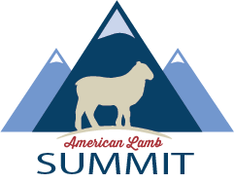

The United Suffolk Sheep Foundation is offering one expense* paid trip to the 2025 American Lamb Summit held at University of Idaho, Moscow, Idaho - July 23-25. The American Lamb Summit is an educational conference designed to inspire production improvements and collaboration among all segments of the US lamb industry The application deadline is June 9.

Application Requirements:
Open to any USSA or UJSSA member who is 18 years of age or older.
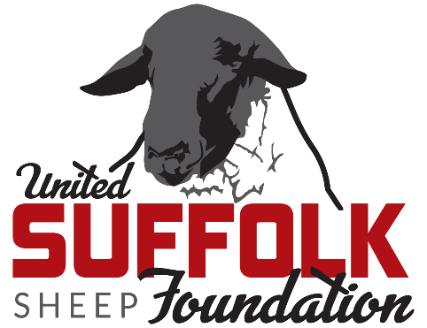
*Grant Covers:
Funded by:
Registration fee for the event
Up to three night’s lodging
Travel expenses (airfare or mileage)
Receipts will be required for reimbursement

Applications should be emailed to info@suffolks.org, subject line: Suffolk Foundation American Lamb Summit Travel Grant. For questions, please contact the Suffolk Office at 641.684.5291.

Name ____________________________________________________________________________________________

Address __________________________________________________________________________________________

City _____________________________________ State __________________________ Zip ________________

Email ____________________________________ Cell phone __________________________________________

USSA Member _____yes _____no UJSSA Member _____yes _____no

Please answer the questions below. Sections can be expanded for additional space if needed.

Related sheep or agricultural organizations in which you participate

Have you previously attended and or heard of the American Lamb Summit?

What specific idea(s) do you have to increase interest in the Suffolk breed?

Describe your sheep operation (size, type, years of experience, etc.) and plans for the future.

Share your experience in the sheep industry.

What role do you see the Suffolk breed playing in production of American lamb?

What would you hope to learn by attending the American Lamb Summit?

How did you hear about this Suffolk Foundation opportunity?
Facebook Email USSA Member UJSSA Member Other ____________________

