
Young Producer Suffolk Event
Travel Grant
Application Deadline: March 15
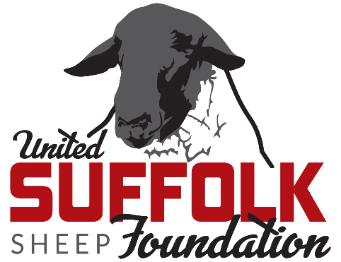
The United Suffolk Sheep Foundation is offering up to four travel grants to attend the 2026 Suffolk Event in Lebanon, Indiana, June 5-7. A preliminary schedule is provided below, up-to-date details about The Suffolk Event are posted at www.suffolks.org. The grant application deadline is March 15.
Funded by:
Application Requirements:
Open to young producers of Suffolk sheep who are 18-40 years old.

Grant Reimbursement Covers:
- Registration fee for the event*
- Up to three night’s lodging
- Travel expenses (airfare or mileage)
- The maximum award for each grant is $750. Grantees will need to submit receipts to be reimbursed for expenses.
- Applicant limited to receiving the grant twice.
*Registration is $80 for an individual or $225 for a family. Family registration is reimbursable through the grant.

Application Submission:
Applications should be emailed to info@suffolks.org, subject line: Suffolk Foundation Young Producer Suffolk Event Travel Grant. For questions, please contact the Suffolk Office at 641.684.5291.

2026 Suffolk Event Schedule
Learn more at www.suffolks.org!

Friday, June 5
8:30 am Adult & Youth Educational Session - Boone Co. Fairgrounds/Reproduction Specialty Group
Noon Lunch (provided)
1 pm Adult & Youth Educational Sessions - Boone Co. Fairgrounds/Reproduction Specialty Group
6 pm Welcome Dinner - Boone Co. Fairgrounds
7 pm Desserts & Decisions! Sale Sheep Preview Attendees select National Suffolk Sale Order!

Saturday, June 6
8 am Youth Olympics | Suffolk Cup – Boone Co. Fairgrounds
11:30 am National Suffolk Sale
TBD Attendee Activities & Junior Show Check-in
6 pm Social, Dinner & Suffolk Hall of Fame Recognition - Boone Co. Fairgrounds
Sunday, June 7
8 am Junior Suffolk Show – Boone Co. Fairgrounds

Young Producer Suffolk Event Travel Grant Application
Application Deadline: March 15

Name ____________________________________________________________________________________________

Address __________________________________________________________________________________________

City _____________________________________ State __________________________ Zip ________________

Email ____________________________________ Cell phone __________________________________________

Birthdate _____________________________

Related sheep or agricultural organizations in which you participate ______________________________________

Did you attend The Suffolk Event last year?

What specific idea(s) do you have to increase interest in the Suffolk breed?

Describe your sheep operation (size, type, years of experience, etc.) and plans for the future.

Share your experience in the sheep industry.

What role do you see the Suffolk breed playing in the sheep industry?

What would you hope to learn by attending The Suffolk Event?

Complete the estimated budget worksheet below for your travel to The Suffolk Event.

 | Estimated $ | Comments/Notes
Registration
Hotel
Mileage($0.65/mile)
Airfare
Car Rental/Transportation
Other
Total

Please include any additional information you would like to share with the selection committee.

How did you hear about this Suffolk Foundation opportunity?
Facebook Email USSA Member Other ______________________

